DBS201 Final Assignment

Jihyun Gong

Junsung Lim

Seung Ho Nam

Yeonju Hong

Seneca College

DBS201SEE

Professor Lydia Li

December 5, 2018

* UV#1

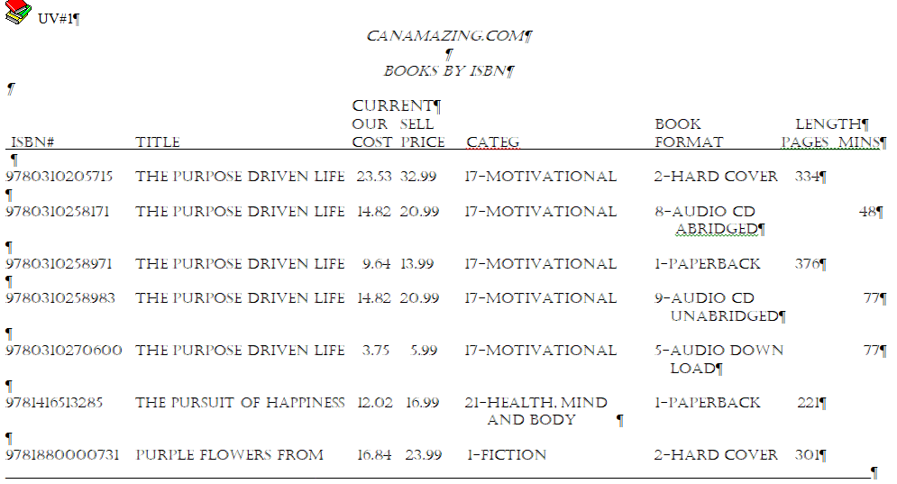

UNF:

Book [ ISBN, Title_Name, Category_No, Category, OG_Price, Current_Price, Format_No, Format, Pages, Mins ) ]

1NF:

Book [ ISBN_No, Title_Name, Category_No, Category, OG_Price, Current_Price, Format_No, Format, Pages, Mins ]

2NF:

Book [ ISBN_No, Title_Name, Category_No, Category, OG_Price, Current_Price, Format_No, Format, Pages, Mins ]

3NF:

Book [ ISBN_No, Title_Name, Category_No(FK), OG_Price, Current_Price, Format_No(FK), Pages, Mins ]

Cate [ Cate#, Category ]

Format [ Format#, Format ]

* UV#2

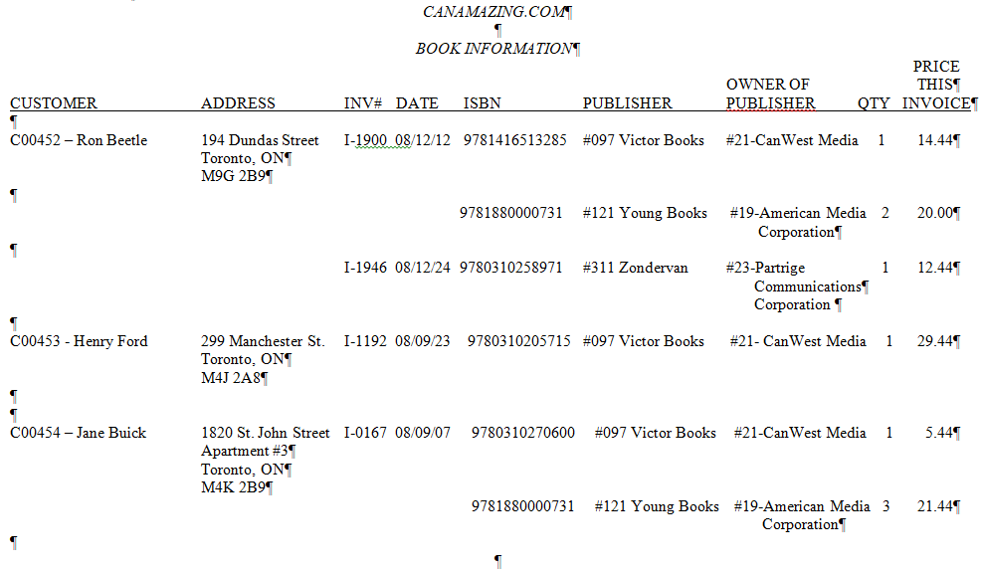

UNF:

Book [ Customer_No, Customer_Name, Street, City, Province, Postal_Code, (Invoice_No, Date, (ISBN_No, Publisher_No, Publisher, Owner_No, Owner, Qty, Price)) ]

1NF:

Book [ Customer_No, Invoice_No, ISBN_No, Customer_Name, Street, City, Province, Postal_Code, Date, Publisher_No, Publisher, Owner_No, Owner, Qty, Price ]

2NF:

Book [ Customer_No, Invoice_No, ISBN_No , Qty, Price ]

Customer [ Customer_No, Customer_Name, Street, City, Province, Postal_Code]

Invoice [ Invoice_No, Date ]

ISBN [ ISBN_No, Publisher_No, Publisher, Owner_no, Owner ]

3NF:

Book [ Customer_No (FK), Invoice_No (FK), ISBN_No (FK), Qty, Price ]

Customer [ Customer_No, Customer_Name, Customer_Address ]

Invoice [ Invoice_No, Date ]

ISBN [ ISBN_No, Publisher_No (FK) ]

Publisher [ Publisher_No, Publisher, Owner_No (FK)]

Owner [ Owner_No, Owner ]

* UV#3

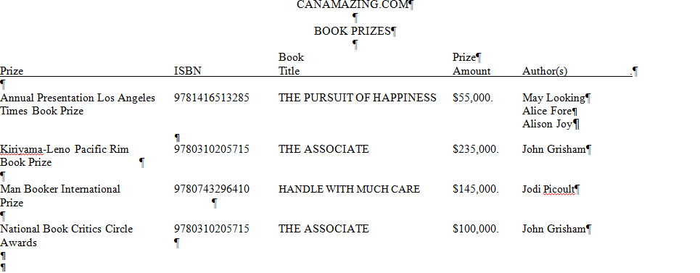

UNF:

[ ISBN, Title, (Prize#, Prize, Prize_Amount, (Author_ID, Author)) ]

1NF:

[ ISBN, Author_ID, Prize#, Title Prize, Prize_Amount, Author ]

2NF:

ISBN_Author_Prize [ ISBN, Author_ID, Prize# ]

ISBN [ ISBN, Title ]

Prize [ Prize#, Prize, Prize_Amount ]

Author [ Author_ID, Author ]

3NF:

ISBN_Author_Prize [ ISBN(FK), Author_ID(FK), Prize#(FK) ]

ISBN [ ISBN, Title ]

Prize [ Prize#, Prize, Prize_Amount ]

Author [ Author_ID, Author ]

* UV#4

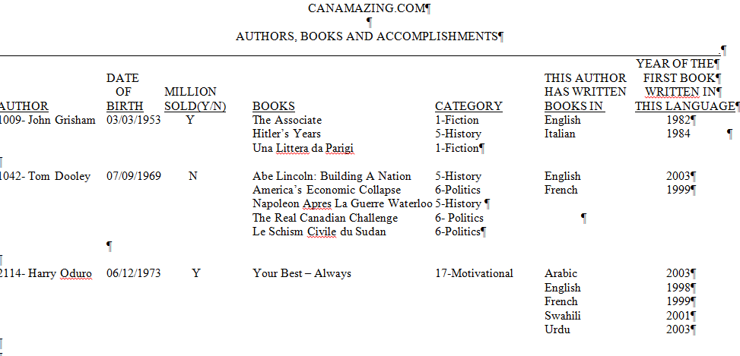

UNF:

[ Author#, Author, DateOfBirth, MillionSold, ( ISBN, Title, Cate#, Category, ( Language#, Language, YearOfFirstBook ) ) ]

1NF:

[ Author#, ISBN, Language#, Author, DateOfBirth, MillionSold, Title, Cate#, Category, Language, YearOfFirstBook ]

2NF:

AuthorISBNLang [ Author#, ISBN, Language, YearOfFirstBook ]

Author [ Author#, Author, DateOfBirth, MillionSold ]

ISBN [ ISBN, Title, Cate#, Category ]

3NF:

AuthorTitleLang [ Author# (FK), ISBN (FK), Language, YearOfFirstBook ]

Author [ Author#, Author, DateOfBirth, MillionSold ]

BOOK [ ISBN, Title, Cate# (FK) ]

Category [ Cate#, Category ]

* UV#5

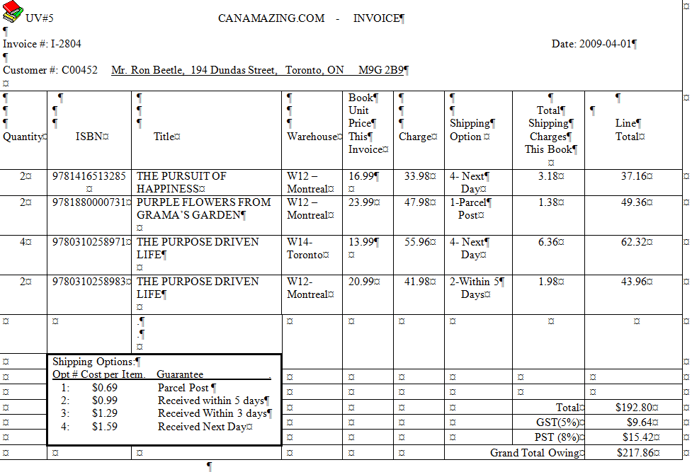

UNF: [ Invoice#, InvoiceDate, Cust#, CustName, CustAddress, ( Qty, ISBN, Title, Warehouse#, Warehouse, Price, Shipping_Option#, Shipping_Option, Shipping_Charge ) ]

1NF:

[ Invoice#, ISBN, InvoiceDate, Cust#, CustName, CustAddress, Qty, Title, Warehouse#, Warehouse, Price, Shipping_Option#, Shipping_Option, Shipping_Charge ]

2NF:

InvoiceISBN [ Invoice#, ISBN ]

Invoice [ Invoice#, InvoiceDate, Cust#, CustName, CustAddress, Qty, Price, Shipping_Option#, Shipping_Option, Shipping_Charge ]

ISBN [ ISBN, Title, Warehouse#, Warehouse, Price]

3NF:

InvoiceISBN [ Invoice# (FK), ISBN (FK) ]

Invoice [ Invoice#, InvoiceDate, Cust# (FK), Qty, Price, Shipping_Option# (FK) ]

Customer [ Cust#, CustName, CustAddress ]

ISBN [ ISBN, Title, Warehouse# (FK) ]

Warehouse [ Warehouse#, Warehouse ]

Shipping [ Shipping_Option#, Shipping_Option, Shipping_Charge ]

* UV#6

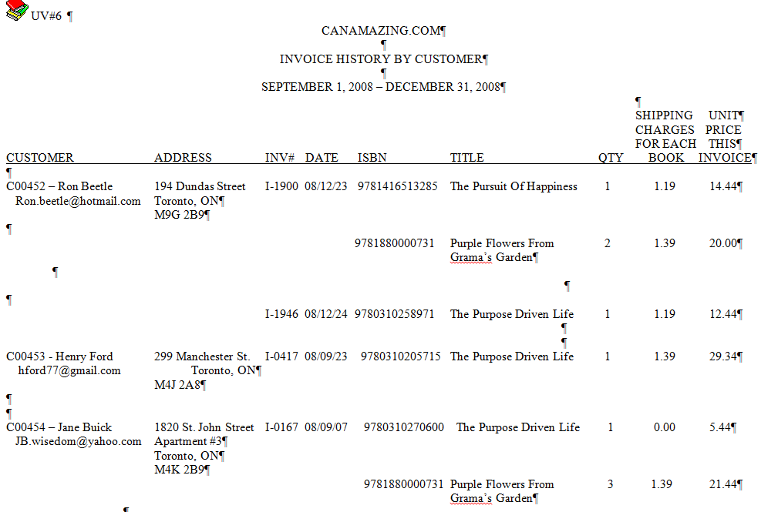

UNF:

[ Cust#, CustName, CustEmail, CustAddress, (Invoice#, Invoice_Date, (ISBN, Title, Qty, Shipping_Charge, Unit_Price ) ) ]

1NF:

[ Cust#, Invoice#, ISBN, CustName, CustEmail, CustAddress, Invoice_Date, Title, Qty, Shipping_Charge, Unit_Price ]

2NF:

CustInvoiceISBN [ Cust#, Invoice#, ISBN ]

Customer [ Cust#, CustName, CustEmail, CustAddress ]

Invoice [ Invoice#, Invoice_Date, Qty, Shipping_Charge, Unit_Price ]

ISBN [ ISBN, Title ]

3NF:

CustInvoiceISBN [ Cust# (FK), Invoice# (FK), ISBN (FK) ]

Customer [ Cust#, CustName, CustEmail, CustAddress ]

Invoice [ Invoice#, Invoice_Date, Qty, Shipping# (FK), Unit_Price ]

ISBN [ ISBN, Title) ]

Shipping [ Shipping#, Shipping_Charge ]

* Merge All the 3NF:

Author [ Author_ID, Author, DateOfBirth, MilionSold ]

Author_ISBN_Language[ Author_ID (FK), ISBN (FK), Language, YearOfFirstBook ]

Cate [ Cate#, Category ]

Customer [ Customer_No, Customer_Name, Customer_Address, Cust_Email ]

Cust_Inv_ISBN [ Customer_No (FK), Invoice_No (FK), ISBN (FK), Qty, Price ]

Format [ Format#, Format ]

Invoice [ Invoice_No, Date, Customer_No(FK), Shipping_Option#(FK) ]

Invoice_ISBN [ Invoice# (FK), ISBN (FK) , Qty, Price]

ISBN [ ISBN, Title_Name, Category#(FK), OG_Price, Current_Price, Format#(FK), Pages, Mins , Publisher_No(FK) , Warehouse# (FK) ]

ISBN_Author_Prize [ ISBN(FK), Author_ID(FK), Prize#(FK) ]

Owner [ Owner_No, Owner ]

Prize [ Prize#, Prize, Prize_Amount ]

Publisher [ Publisher#, Publisher, Owner_No (FK)]

Shipping [ Shipping_Option#, Shipping_Option, Shipping_Charge ]

Warehouse [ Warehouse#, Warehouse ]

* Permission

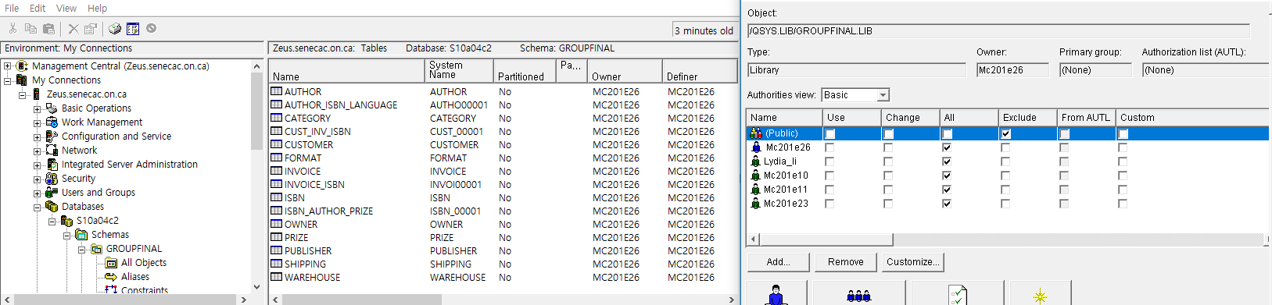

* ERD

